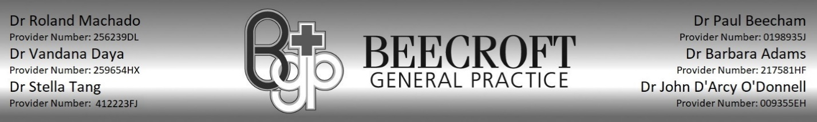Fee Schedule

From November 2024

|  |  |  |  |
| --- | --- | --- | --- |
| Consultation Fees (Monday-Friday) *(in surgery Monday-Friday 8am-6pm)* | | | |
| **Consultation type**  **In Rooms** | **Duration** | **Fee charged (Medicare rebate)** | **Out of pocket** |
| Level A Short Consultation | Less than 7  minutes | $ 29.60 $ 19.60 | **$ 10.00** |
| Level B *standard consultation*  *Students/Seniors*  *Concession* | Less than 20 minutes | $ 90.00 $ 42.85    $ 75.00 $ 42.85    $ 75.00 $ 42.85 | **$ 47.15**  **$ 32.15**  **$ 32.15** |
| Level C *long consultation*  *Students/Seniors*  *Concession* | At least 20 minutes | $ 140.00 $ 82.90    $ 120.00 $ 82.90    $ 120.00 $ 82.90 | **$ 57.10**  **$ 37.10**  **$ 37.10** |
| Level D *prolonged consultation*  *Students/Seniors*  *Concession* | At least 40 minutes | $190.00 $ 122.15    $160.00 $ 122.15    $160.00 $ 122.15 | **$ 67.85**  **$ 37.85**  **$ 37.85** |

**We offer bulk billing to**

* Holders of concession cards & Health care cards
* Children under the age of 16
* DVA card holders
* Children’s/Adult immunizations
* Chronic Disease management plans

**Please note above Concession rates does not apply on Saturdays**

We are a private billing medical practice and appreciate full payment of fees on the day of consultation. We use Medicare online so the Medicare rebate can be immediately refunded to your bank account.

Please be advised that we offer a discounted out-of-pocket rate for our senior card holders, with billing determined at the doctor's discretion. If payment presents a challenge, we encourage patients to discuss it directly with their doctor.

Fees may apply for recall and follow-up appointments, depending on the duration and complexity of the consultation.

Telehealth appointments will incur an out-of-pocket fee unless the patient meets the eligibility criteria under Medicare or is registered with My Medicare.

Patients that have not visited the doctor in person in the last 12 months do not meet the Medicare rebate eligibility criteria and must pay the full fee for a telehealth appointment.

Thank you for your understanding. If you have any questions, please don't hesitate to reach out to our friendly staff.